|  |  |  |  |  |  |  |  |  |  |  |  |
| --- | --- | --- | --- | --- | --- | --- | --- | --- | --- | --- | --- |
| **Mapbox Studio Components** | | **Zoom Levels** | **Form** | | **Color** | | **Type** | | **Texture** | | |
| **Administrative Boundaries**   * *admin-0-boundary* * *admin-1-boundary* * *admin-0-boundary-disputed* | | [roughly plan when these layers may toggle on and off when zooming] | [paste example crops from your inspiration board here; you do not need to fill out every box, rather this plans which OSM layers might make the most sense to recreate your visual style] | | #f3f0df | |  | |  | | |
| **Buildings**  **(including labels)**   * *block-number-label* * *building-number-label* * *building* * *building-extrusion* * *building-underground* | |  |  | |  | |  | |  | | |
| **Land** & Water   * *land* * *landcover* * *national-parks* * *landuse* | |  |  | |  | |  | |  | | |
| Land & **Water**   * *water* (+ shadowing) * *waterway* (+ shadowing) * *land-structure* (structures on the coastlines; lines and polygons) | |  |  | |  | |  | |  | | |
| **Natural Features (Labels)**   * *water-point-label* * *water-line-label* * *natural-point-label* * *natural-line-label* * *waterway-label* | |  |  | |  | |  | |  | | |
| **Place Labels**   * *country-label* * *state-label* * *settlement-major-label* * *settlement-minor-label* * *settlement-subdivision-label* | |  |  | |  | |  | |  | | |
| **Points of Interest**   * *poi-label* (text or icon; Maki is used by default) | |  |  | |  | |  | |  | | |
| **Mapbox Studio Components** | **Zoom Levels** | | | **Form** | | **Color** | | **Type** | | **Texture** |
| **Road Network**  **(including labels)**  Complex hierarchy avail within the following categories:   * *road-labels* * *bridge* * *turning-feature* (e.g., one-way) * *road* * *tunnel* |  | | |  | |  | |  | |  |
| **Satellite Imagery**   * *satellite* (can fade in a largest zoom level) * *background* |  | | |  | |  | |  | |  |
| **Terrain**   * *hillshade* * *cliffs* * *contours* |  | | |  | |  | |  | |  |
| **Transit (including labels)**   * *aerialway* * *bridge-raile-tracks* * *bridge-rail* * *road-rail-tracks* * *road-rail* * *ferry-auto* * *ferry* * *aeroway-line* * *aeroway-polygon* |  | | |  | |  | |  | |  |
| **Walking, Cycling (including labels)**   * *bridge-pedestrian* (+ many related categories) * *golf-hole-line* * *road-pedestrian* (+ many related categories) * *tunnel-pedestrian* (+ many related categories) |  | | |  | |  | |  | |  |
| **Custom Datasets**  Mapbox Studio supports csv, geojson, kml, gpx, shapefile, and geotiff formats. All custom datasets must first be reprojected into Web Mercator (EPSG:3857) |  | | |  | |  | |  | |  |
| **Background Layer** |  | | |  | |  | |  | |  |

Example

* BARBARA KRUGER "[SURVEILLANCE](https://www.caviar20.com/products/barbara-kruger-surveillance-1983?srsltid=AfmBOooB58PrT4fDw1Kf4ywsfQC9hyzlRz243isYOM100F8ueXcFCYTG)", 1983

* El Lissitzky “Beat the Whites with the Red Wedge”, 1919

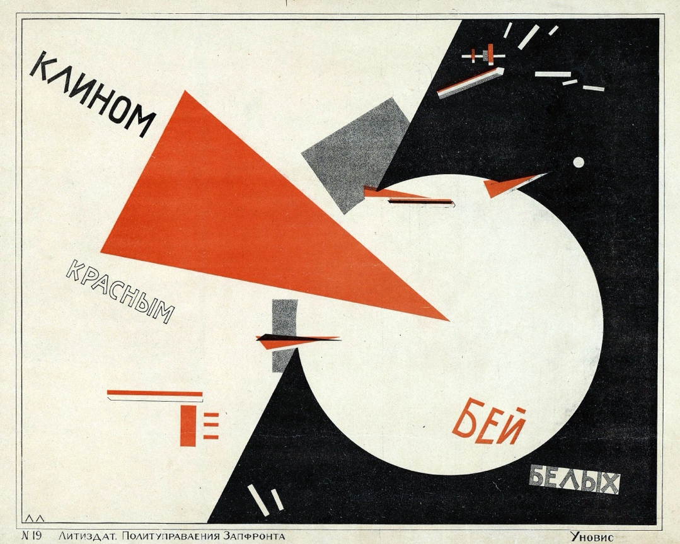

* Dystopian Survalliance

Shepard Fairey, “[Surveillance](http://mutualart.com/Artwork/Surveillance/B97C1D7D616D0EB50708F27BEBFB0703)”, 1996

